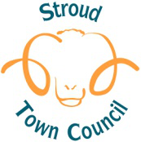
Document 6

Stroud Town Centre Local Heritage Assets List: Selection Panel Tasks

- To assess nominations for inclusion on the Stroud Town Centre Local Heritage Assets List against the criteria shown in Appendix 5 of the Stroud Town Centre Neighbourhood Development Plan.

- To recommend to Stroud Town Council a draft shortlist of local heritage assets which will be subject to public consultation, including consultation with owners.

- To carry out an annual review of the Local Heritage Assets List, including:
- the assessment of any additional nominations to the list
- the assessment of any proposals to remove an asset from the list

